# CS 255 System Design Document

## UML Diagrams

### UML Use Case Diagram

### UML Activity Diagrams

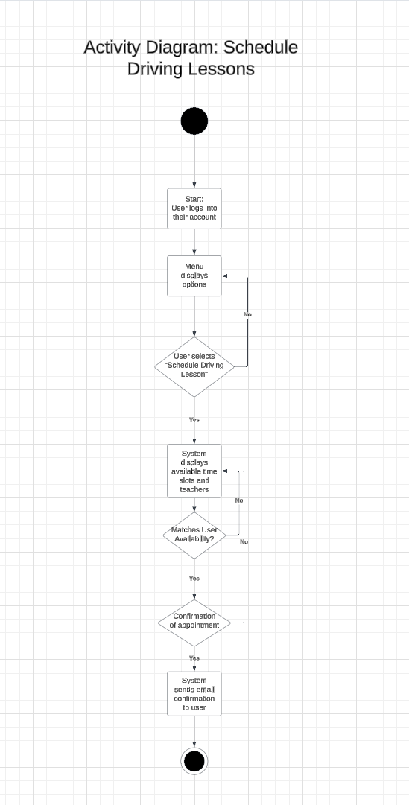

### UML Sequence Diagram

### UML Class Diagram

## Technical Requirements

Based on the functional and nonfunctional requirements detailed in the DriverPass business requirements document, the proposed system requires a robust set of technical specifications to ensure efficiency, reliability, and scalability.

For hardware, the system will depend on cloud-based servers to host the application, ensuring high availability and scalability. End users, including students, instructors, and administrators, will access the system using desktops, laptops, tablets, or smartphones, necessitating compatibility across a range of devices. High-speed internet connectivity is essential for seamless data exchange and system functionality. Additionally, secure, redundant storage solutions are required for safeguarding system data and providing reliable disaster recovery capabilities.

From a software perspective, the system will be web-based, compatible with major operating systems such as Windows, macOS, Linux, iOS, and Android. A relational database management system like MySQL or PostgreSQL will manage user data, lesson schedules, and exam results, while a web server software such as Apache or NGINX will host the system. For development, frameworks like Django or Flask for the back-end and React or Angular for the front-end will ensure a user-friendly interface. The system must also support all major web browsers, including Chrome, Firefox, Safari, and Edge.

In terms of tools, developers will use IDEs such as Visual Studio Code or PyCharm for system development, with Git employed for version control to track changes and facilitate collaboration. Automated testing tools like Selenium or JUnit will ensure that the system functions as expected, and monitoring tools like Nagios or New Relic will be used to maintain system performance and address potential issues proactively.

The infrastructure requirements include cloud-hosting services such as AWS, Azure, or Google Cloud to ensure redundancy, scalability, and reliable operation. Security measures are critical, including SSL certificates for secure data transmission, multi-factor authentication for user login, and firewall and antivirus protections to safeguard the system from external threats. Regular automated backups using cloud-based solutions will ensure data recovery in case of system failures, and the infrastructure must be scalable to accommodate growth in user demand.

These technical requirements provide a comprehensive foundation for developing a secure, scalable, and user-friendly system that meets DriverPass's objectives while addressing the needs of all stakeholders.